Nikto Web Server Vulnerability Scan Report

1. Introduction
Nikto is an open-source web server scanner used to identify potential vulnerabilities, misconfigurations, and security issues on web servers. It is widely used by penetration testers and security professionals for initial reconnaissance and vulnerability assessment phases. Nikto comes pre-installed with Kali Linux, making it readily available for use.

2. Scan Methodology
For this assessment, Nikto was already pre-installed on Kali Linux. The following command was used to scan the target host:
nikto -h https://zacademypk.com -o scan_resultszacademy.txt -Format text
This command scanned the target (zacademypk.com) over HTTPS (port 443) and saved the scan results in a text file named 'scan_resultszacademy.txt'.

3. Screenshot of the Scan
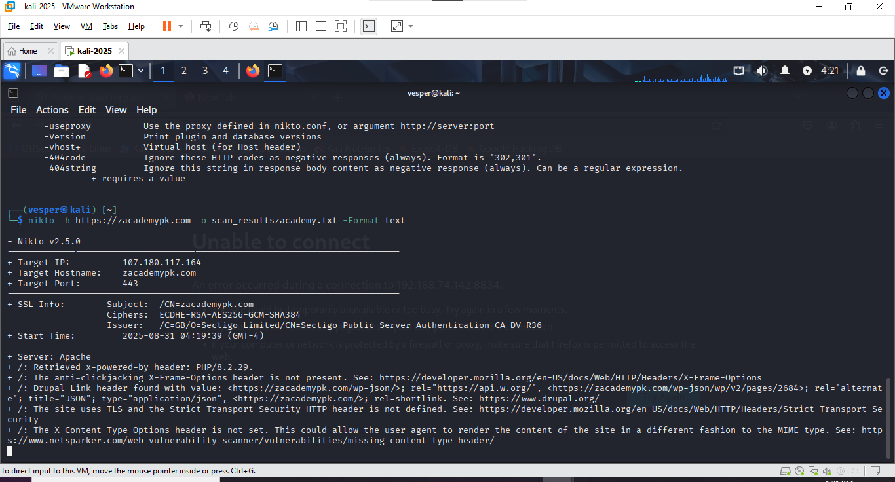

4. Viewing Scan Results
To view the saved scan results, the following command was used:
cat scan_resultszacademy.txt
This displayed the findings in the terminal.
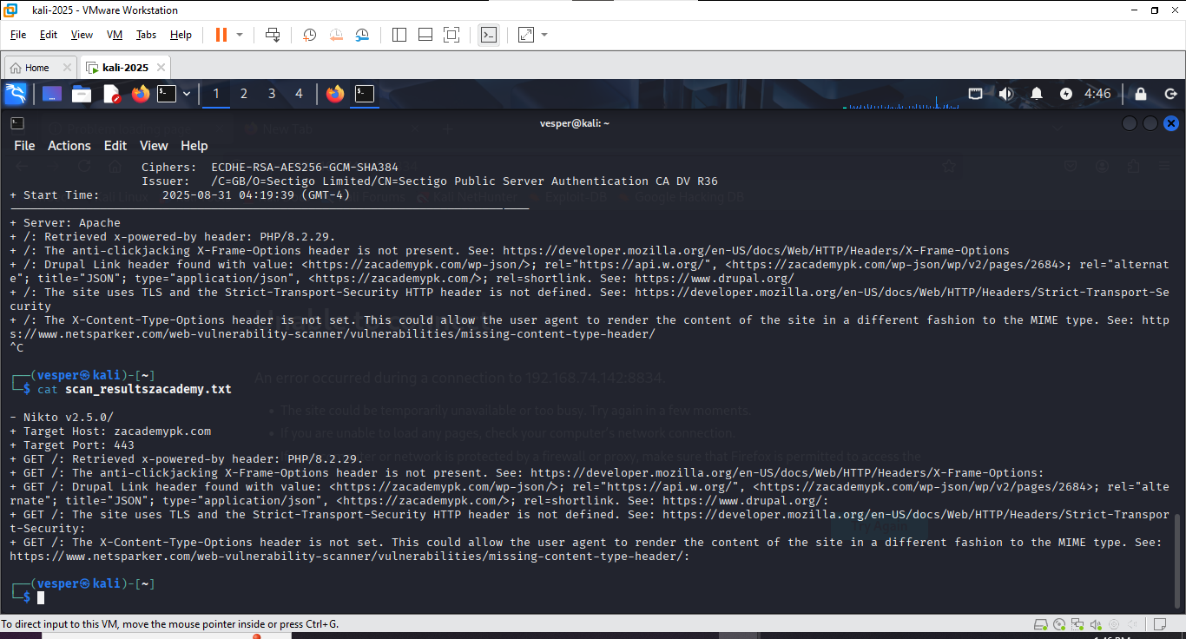

5. Findings and Recommendations

5.1 Information Disclosure: x-powered-by Header
Finding: The server discloses its technology stack via the 'x-powered-by' header (PHP/8.2.29).
Risk Level: Medium
Impact: Attackers can identify the PHP version and target known vulnerabilities.
Recommendation: Disable or remove the x-powered-by header.
For PHP/Apache, set 'expose_php = Off' in php.ini and restart Apache using:
sudo systemctl restart apache2

5.2 Missing X-Frame-Options Header
Finding: The server does not implement the X-Frame-Options header.
Risk Level: Medium
Impact: This exposes the site to clickjacking attacks.
Recommendation: Add the header to prevent framing by other domains:
Apache: Header always append X-Frame-Options SAMEORIGIN
Nginx: add_header X-Frame-Options "SAMEORIGIN";

5.3 Missing Strict-Transport-Security (HSTS) Header
Finding: The Strict-Transport-Security header is not set.
Risk Level: Medium to High
Impact: Users may be downgraded to insecure HTTP connections, risking man-in-the-middle attacks.
Recommendation: Add the HSTS header:
Apache: Header always set Strict-Transport-Security "max-age=31536000; includeSubDomains; preload"
Nginx: add_header Strict-Transport-Security "max-age=31536000; includeSubDomains; preload";

5.4 Missing X-Content-Type-Options Header
Finding: The server does not send the X-Content-Type-Options header.
Risk Level: Low to Medium
Impact: Without this header, browsers may misinterpret file types, potentially leading to XSS or malicious file execution.
Recommendation: Add the header:
Apache: Header set X-Content-Type-Options "nosniff"
Nginx: add_header X-Content-Type-Options "nosniff";

5.5 Drupal/WordPress Link Header Disclosure
Finding: The server exposes 'Link' headers revealing WordPress/Drupal API endpoints.
Risk Level: Low to Medium
Impact: Reveals the technology stack and potentially exposes API endpoints that may be exploited if vulnerable.
Recommendation: Remove unnecessary Link headers and disable JSON API endpoints if not used.
For WordPress, add this to functions.php:
remove_action('wp_head', 'rest_output_link_wp_head');
remove_action('wp_head', 'wp_oembed_add_discovery_links');

6. Advantages of Using Nikto
- Free and open-source
- Pre-installed in Kali Linux
- Detects a wide range of common vulnerabilities quickly
- Easy to use with simple command-line options
- Supports multiple output formats (HTML, TXT, XML)

7. Conclusion
Nikto is an essential tool for initial web server vulnerability assessments. While it may produce some false positives, it provides quick insights into server misconfigurations and missing security headers. The scan on zacademypk.com revealed several missing security headers and information disclosure issues that, once resolved, will enhance the security posture of the web server.

